**Hands-On Lab/Demo Script**

**Java Development on Linux with Visual Studio Team Services**

# Overview and Acquiring the VM

Lab version: 1.1.0

Last updated: 3/7/2016



### Overview

Visual Studio Team Services makes your software lifecycle better and faster letting you code in Eclipse, IntelliJ, or your favorite Java IDE. You get free unlimited private Git repositories, agile planning and work item tracking tools, and support for builds and continuous integration using Ant, Maven, or Gradle.

The VSTS for Java on Ubuntu Virtual Machine Virtual Machine is a pre-configured, ready to run image on Azure and comes with a set of Hands-On-Labs/Demo scripts to help anyone who wants to learn how Visual Studio Team Services (and Team Foundation Server) provide cross platform tools that enable you to easily build Java solutions.

The virtual machine contains the following pre-configured software:

* Ubuntu Linux 14.04 LTS
* Eclipse Java EE IDE for Web Developers Mars Release 4.5.0
* Microsoft Team Explorer Everywhere Plug-in for Eclipse 14.02.201512281640
* Visual Studio Code 0.10.6
* Microsoft VSTS Cross Platform Build and Release Agent 1.999.0
* Firefox 44
* Oracle Java 1.7.0_05
* Oracle MySQL 5.6.28
* Apache Tomcat 7.0.52
* Apache Maven 3.0.5
* Git 1.9.1
* Gradle 2.7
* NPM 3.3.12
* Node.js 5.5.0
* Sample users and data required to support hands-on-labs which accompany this download.

A set of hands-on-lab documents, which also function as demo scripts, are available for download along with this virtual machine. There are 11 exercises in this walkthrough:

1. Creating Your Visual Studio Team Services Account and Team Project
2. Managing Your Backlog
3. Working with Git
4. Building your application, running unit tests and code coverage
5. Working with Team Explorer Everywhere
6. Setting up Build and Release Agent on Linux
7. Collaborating on code changes with Pull Requests
8. Using Release Management to deploy your application to Tomcat
9. Running Automated UI Test with Selenium
10. Deploying to Azure
11. Monitoring with Application Insights

Once you get your team environment set up, you’ll start working on an Intranet site for a fictitious company, MyShuttle.biz, where you’ll update the site, deploy it and test it all with the VM you’re using and Visual Studio Team Services.

### Prerequisites

* 1. **VSTS for Java on Linux VM 2016:** In order to complete this lab, you will need the VSTS for Java on Linux VM 2016 virtual machine provided by Microsoft. The virtual machine can be either downloaded and run locally on Hyper-V or can be instantiated and run on Azure. For more information on acquiring and using this virtual machine, please see the next section.
  2. **Target Audience:** The image and the accompanying hand-on-labs is for technical audience. As such, familiarity with Visual Studio Team Services, Java and Linux operating system would be preferred although it is not a strict prerequisite.

### Acquiring the VSTS for Java Linux VM 2016

In order to run on Azure, you will need to add the VHD to your Azure storage and use it as an image and create VM based on the image:

The pre-requisites for running the VM on Azure are:

1. An active Azure subscription
2. Azure storage account
3. Azure PowerShell on your local machine

**Uploading the VHD**

1. Download the VHD to your machine – the VHD is available at <https://vstsjl2016vhd.blob.core.windows.net/vhd/vstsjlvhd072216.vhd>. Open a browser to navigate to this URL to download the VHD. Specify a directory where you want the disk to be downloaded
2. Start Azure PowerShell. If you do not have it installed, you can read the instructions on how to download and install Azure PowerShell - <https://azure.microsoft.com/en-us/documentation/articles/powershell-install-configure/>
3. You will need to login to your account – type **Add-AzureAccount** and hit enter. You will be prompted to enter your account credentials. Enter your credentials and if it is successful, you will see the subscriptions associated to the account listed
4. If you have multiple subscriptions, you can use the **Get-AzureSubscription** cmdlet to get the details of the subscriptions associated to the account. To switch to a different subscription, use **Select-AzureSubscription** cmdlet using **–SubscriptionName** or **–SubscriptionID** parameters
5. Use the Add-AzureVhd cmdlet to upload the VHD file to your storage. Type

**Add-AzureVhd** -Destination <BlobStorageURL>/<YourImagesFolder>/<VHDName> -LocalFilePath <PathToVHDFile>

1. Wait for the VHD to finish uploading.
2. Once it is uploaded, login to your azure portal (classic) – <https://manage.windowsazure.com>
3. Select the subscription that the storage account is associated with
4. Go to virtual machines, Select Images from the right-side navigation   
     
   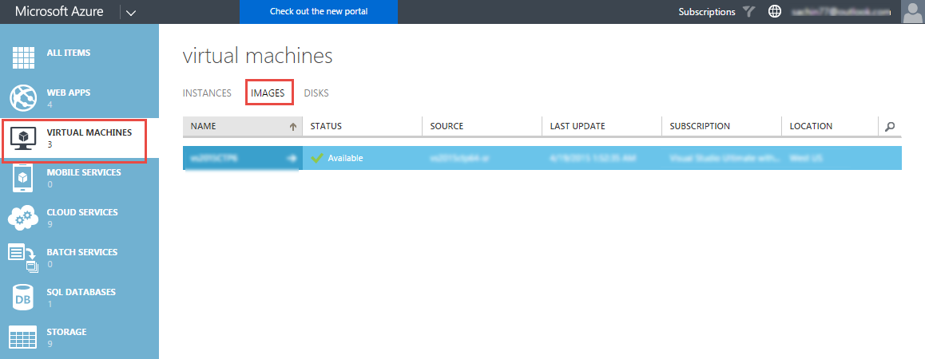
5. Select + Create button on the bottom panel   
   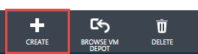
6. Specify a name and description (optional) for the image. Choose the VHD file to populate the URL for the VHD. Make sure that you have select **Linux** as the **Operating System Family** and you have **checked** the “**I have run waagent –deprovision on the virtual machine**” option. Select the Complete button when you are done

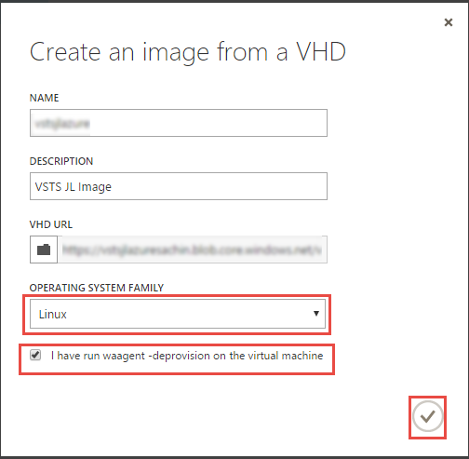

1. Wait for the **Status** to become **available**. Now select **Instances** and select the **+NEW** button at the bottom
2. Select **COMPUTE** – **VIRTUAL MACHINE – FROM GALLERY**  
     
   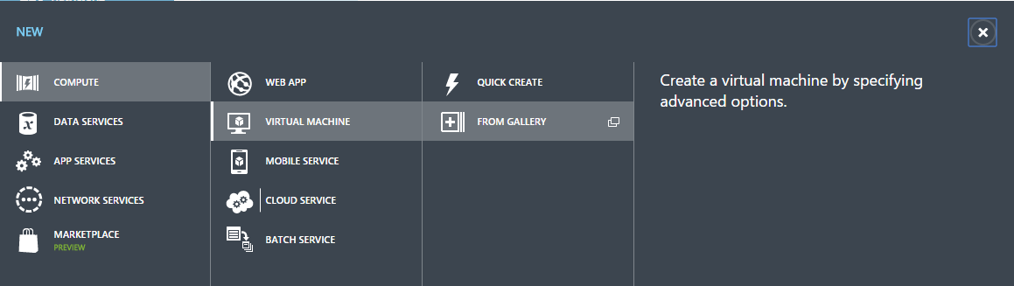
3. Select MY IMAGES and choose the image you just created

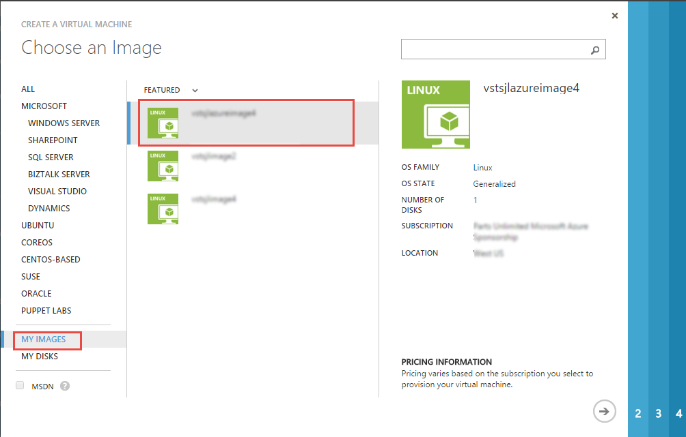

1. Provide a name for the Virtual Machine. Select the tier and Size (7 GB or more recommended) and the authentication method.   
   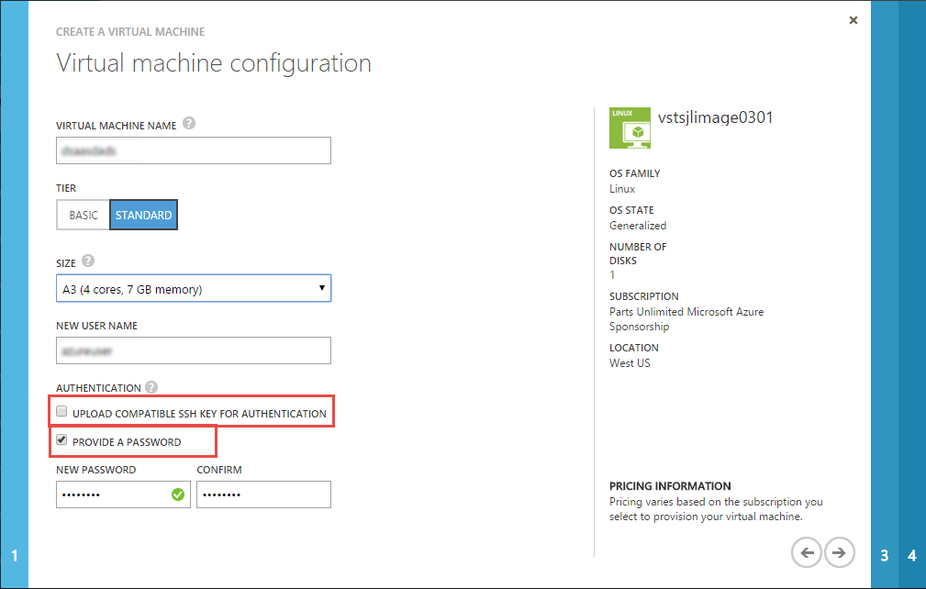
2. In the 3rd page of the wizard, make sure you have added Remote Desktop and HTTP (8080) endpoints  
     
   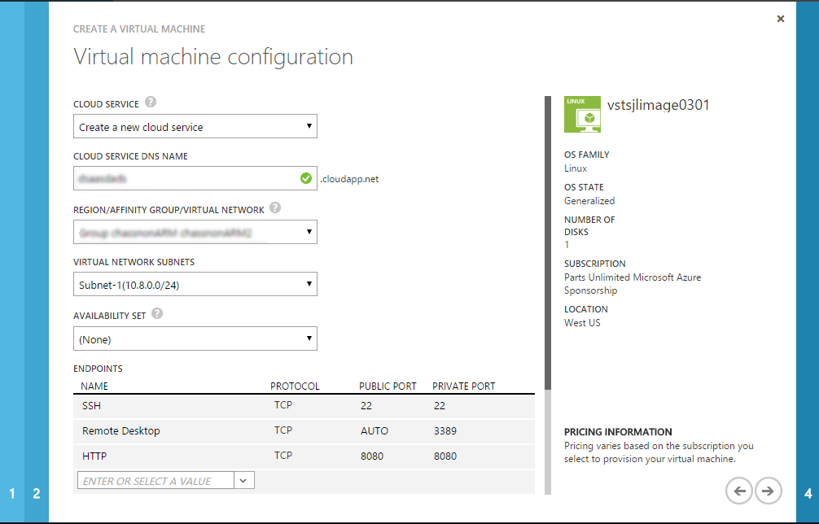
3. Complete the rest part of the Wizard to provision the VM. Once the VM is successfully provisioned. You can download the RDP file to your machine to connect to the VM.

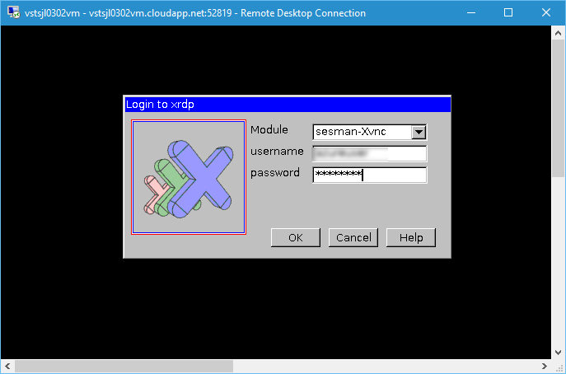

1. Enter the username and password and select **OK** to login to the VM.

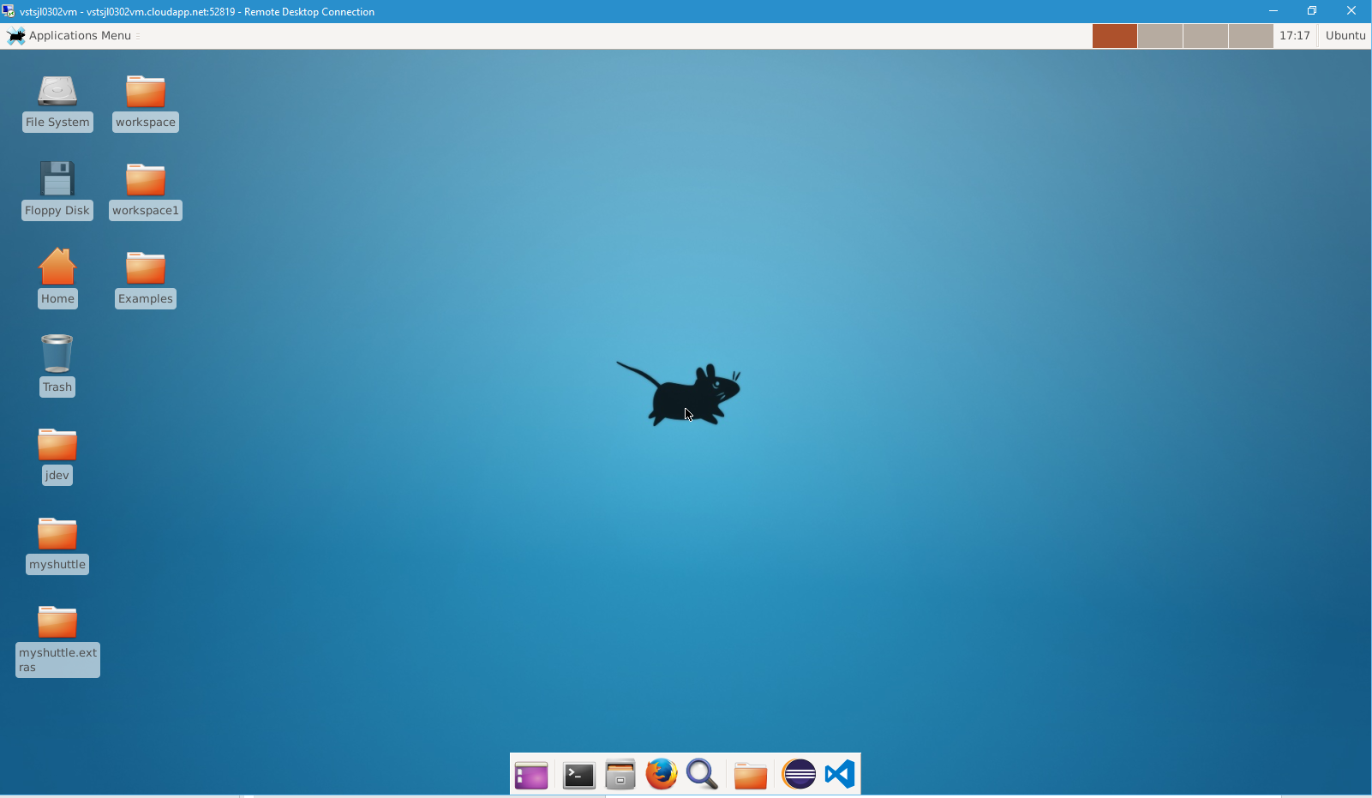

You are now ready to start using the VM!!!

To give feedback please write to [devopsdemos@microsoft.com](mailto:devopsdemos@microsoft.com)

Copyright © 2016 by Microsoft Corporation. All rights reserved.